ContactManagement_Verify Contact notes _Instance44_13-Jul-2018_06-03-32_AM_MouseClickActiononStaleElement.png

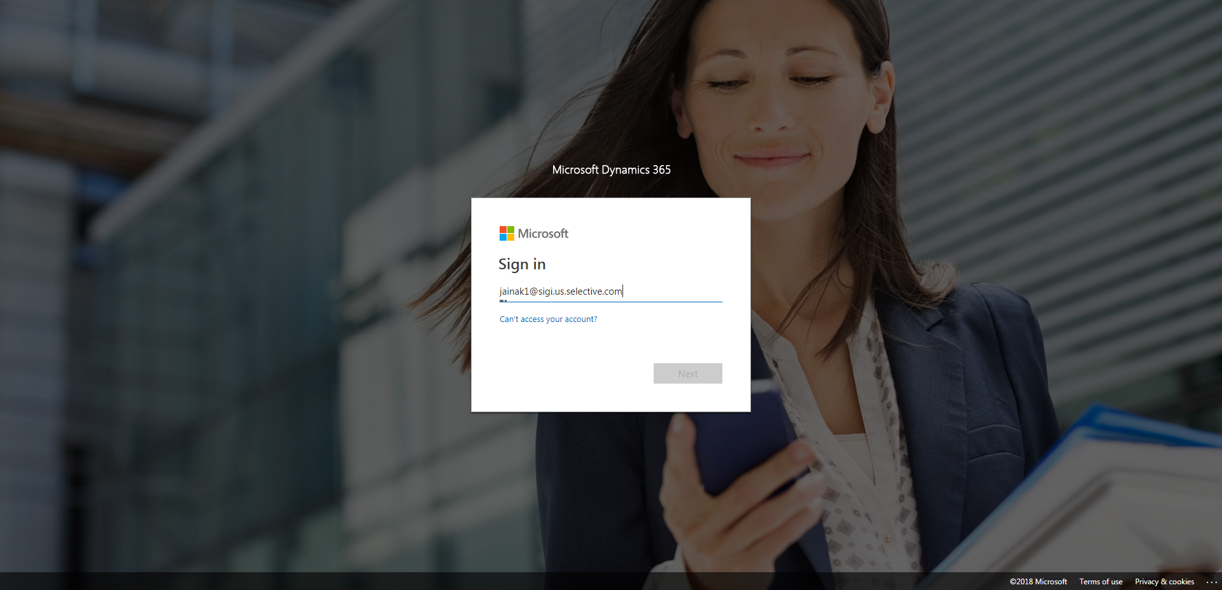

ContactManagement_Verify Contact notes _Instance44_13-Jul-2018_06-03-29_AM_MouseClickActiononStaleElement.png



ContactManagement_Verify Contact notes _Instance44_13-Jul-2018_06-03-44_AM_SingleSignOn.png

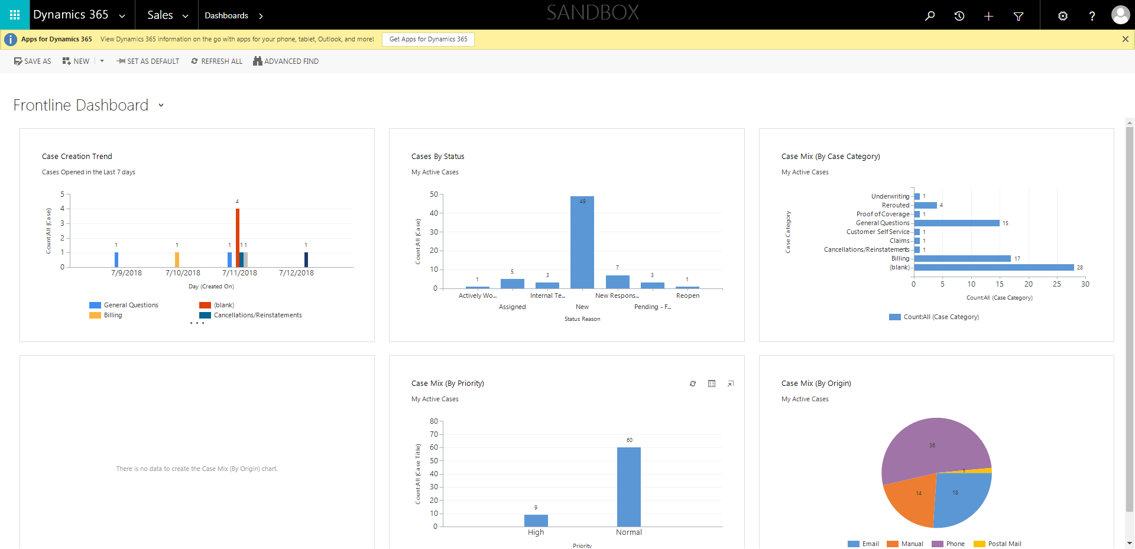

ContactManagement_Verify Contact notes _Instance44_13-Jul-2018_06-03-45_AM_SingleSignOn.png

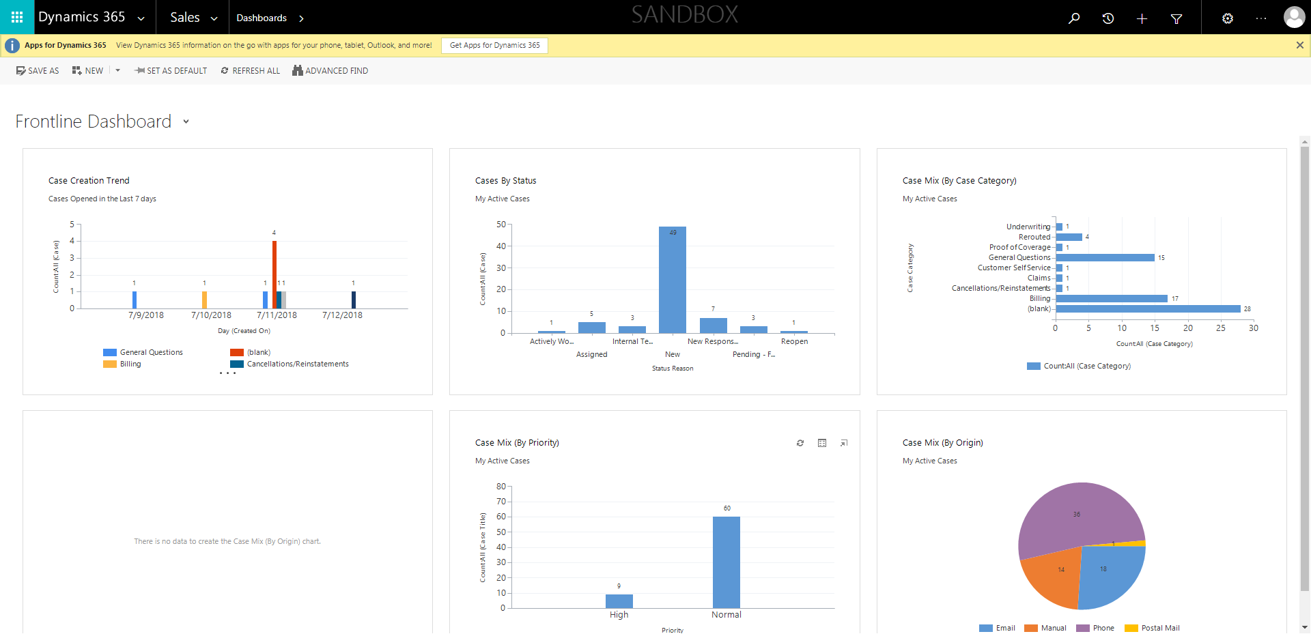

ContactManagement_Verify Contact notes _Instance44_13-Jul-2018_06-04-58_AM_VerifyingAllNotesofanindividual.png

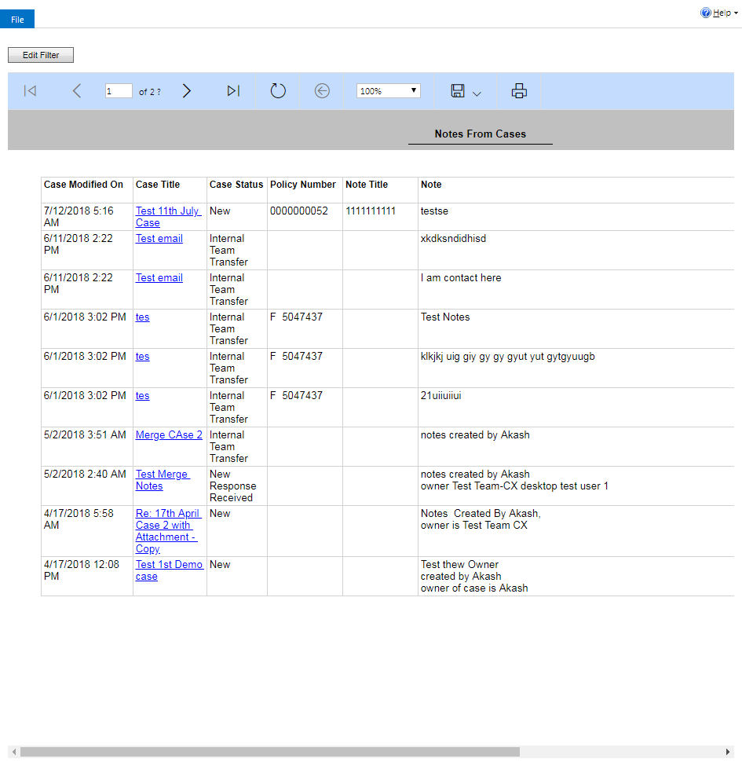

ContactManagement_Verify Contact notes _Instance44_13-Jul-2018_06-03-30_AM_EnterTextAction.png



ContactManagement_Verify Contact notes _Instance44_13-Jul-2018_06-05-17_AM_SingleSignOn.png

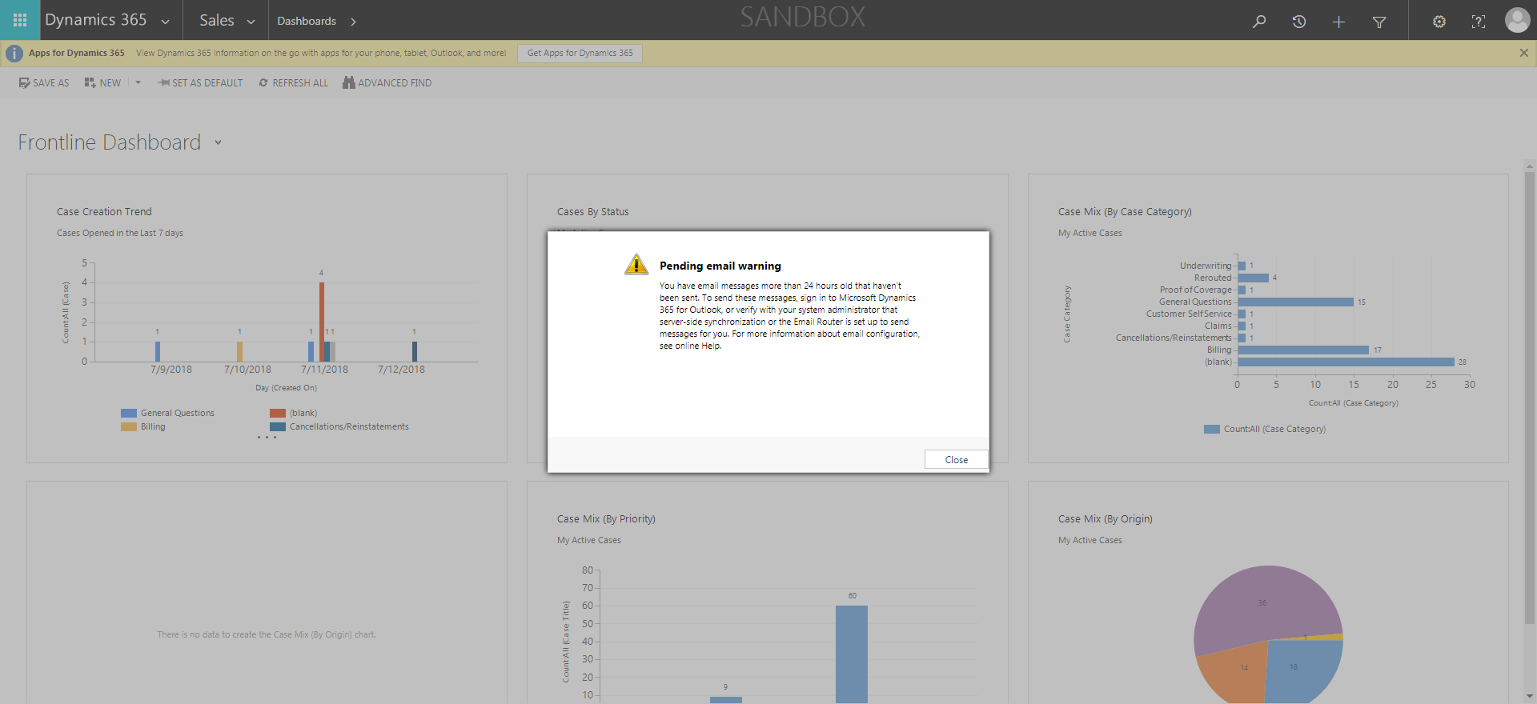

ContactManagement_Verify Contact notes _Instance44_13-Jul-2018_06-04-56_AM_VerifyingLatestNotesofanindividual.png



ContactManagement_Verify Contact notes _Instance44_13-Jul-2018_06-11-08_AM_VerifyingAllNotesofanindividual.png

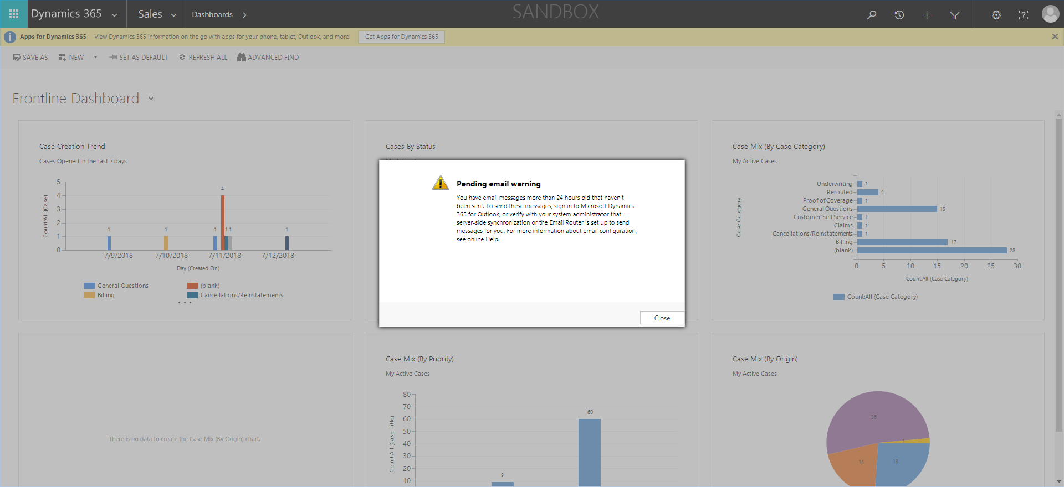

ContactManagement_Verify Contact notes _Instance44_13-Jul-2018_06-04-50_AM_Validatingcontactentitynavigation.png

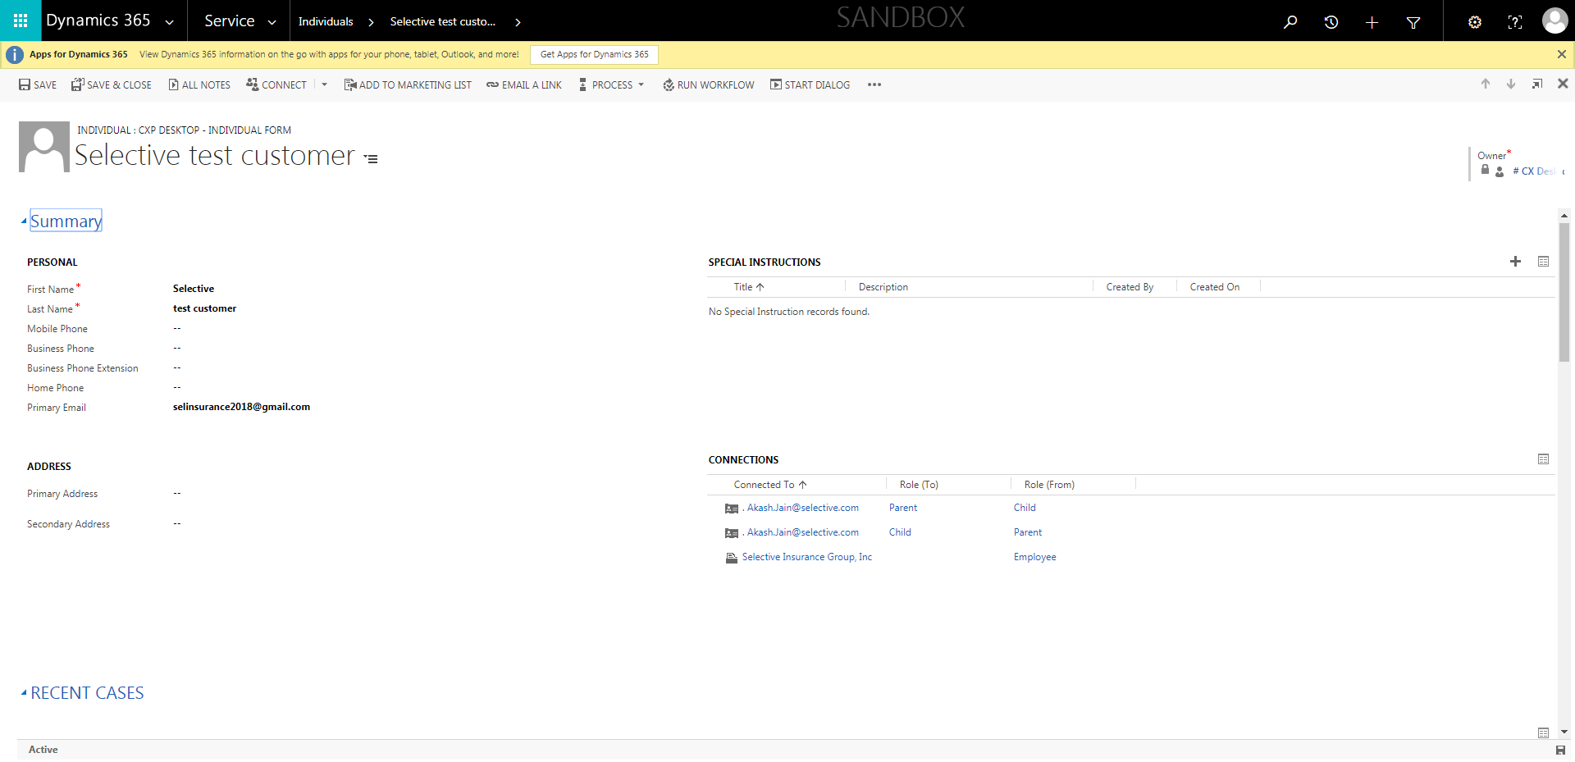

ContactManagement_Verify Contact notes _Instance44_13-Jul-2018_06-10-57_AM_Validatingcontactentitynavigation.png

